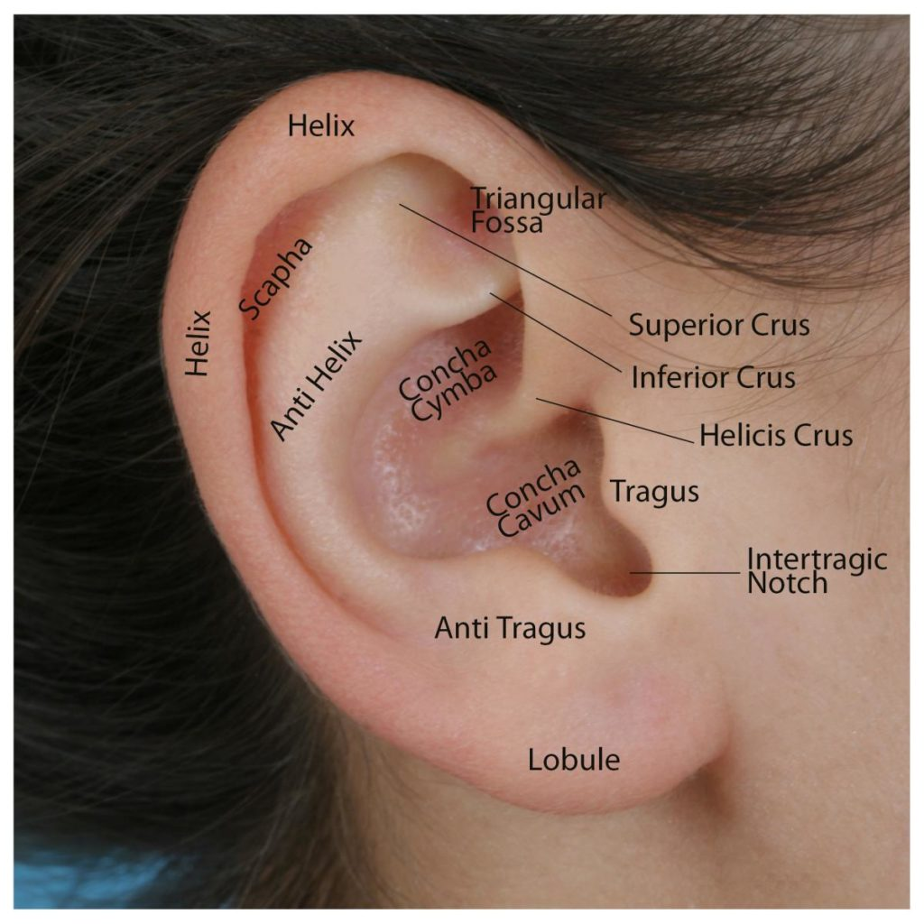

This information leaflet has been produced to inform you about your ears and how to look after them.

How do I clean my ears?

You Don’t!

Your ear canal produces waxy oil called cerumen, which is more commonly known as earwax. This wax protects the ear from dust, foreign particles, and microorganisms. It also protects ear canal skin from irritation due to water. In normal circumstances, excess wax finds its way out of the canal and into the ear opening naturally, and then is washed away. When your glands make more earwax than necessary, it may get hard and block the ear

If you use cotton buds or anything else to clean your ears, you can disrupt the ears’ natural cleaning system. Often the only thing this achieves is to push wax further down the ear canal, making you feel deaf temporarily and causing damage to your ear canal or your ear drum.

If you have had ear surgery the natural cleaning system could be compromised. The change in shape of your ear canal means that wax and debris can build up and so your ears need to be checked and if required to have your ears clean regularly either by the Practice Nurse at your GP surgery or in the Aural Care Clinic.

How do I keep my ears dry?

We may ask you to keep your ears dry for a number of reasons. For example, if you have suffered from frequent infections, preventing water from getting in your ears can help to prevent further infections. We usually ask you to do this when you bathe, wash your hair and swim.

The best way of preventing water getting into your ears is by using cotton wool covered in Vaseline® (petroleum jelly). We recommend that you do the following:
- Using cotton wool, break off a piece which will fit in your ear. Make sure the piece is big enough so that you can easily remove it.
- Roll it into a bullet shape; cover it in Vaseline® and massage Vaseline® into it.
- Put it in your ear and smear some Vaseline® over the top.
- Once you have showered and washed your hair throw the cotton wool plug away.

If you prefer you can use ear plugs but you must make sure they fit properly to create a good seal and do not let the water in.

Sometimes you will be told to keep your ears dry but to use ear drops- this is OK. The drops are to be used to treat a problem. We ask you to prevent water getting in to your ears as this often contributes to infection.

How can I prevent ear wax build up?

Some people are prone to produce too much earwax. Still, excess wax doesn’t automatically lead to blockage. In fact, the most common cause of earwax blockage is at-home removal. Using cotton swabs, bobby pins, or other objects in your ear canal can also push wax deeper, creating a blockage. You’re also more likely to have wax buildup if you frequently use earphones and hearing aids (hearing aids should be removed before going to bed). They can inadvertently prevent earwax from coming out of the ear canals and cause blockages.
What should I use for softening ear wax?

There are a number of over the counter ear drops you can buy and use to soften wax. We recommend the use of olive oil. This can be the same as olive oil you cook with; alternatively you can buy small bottles, which has a pipette from your local chemist.

If you wear hearing aids it is better to use sodium bicarbonate ear drops or spray as the olive oil can block your hearing aid.

How should I put drops in my ear?

If possible get some one else to do it for you.
- You should warm the drops/olive oil to body temperature before putting them in
- Lay on your side with ear to be treated uppermost.
- Put the recommended number of drops into your ear. If you are using olive oil, just put in a few drops.
- Use your finger to push on the small area at the front of your ear (tragus) as if you were trying to block your ear from a loud noise. Do this a few times to assist the drops in.
- Stay on your side for 5 minutes (use a clock to time it) to make sure the drops soak in.
- You can put a piece of cotton wool covered in Vaseline® into your ear as a temporary measure to stop any drops running out again.

If you are to treat both ears then wait for a while before treating the other ear.

What can I do when my ears itch?

Do not be tempted to scratch your ears or poke anything in them to stop the itching.

If your ears itch then, you can just use cold olive oil or buy a product over the counter called EarCalm® Spray. It is a mild vinegar solution and helps to restore the natural acidity of your ear canal. Patients often find that if they make lots of wax their ears itch. The EarCalm® Spray will help this.

Sometime your ears itch because you have a skin condition such as eczema or psoriasis. This will need to be diagnosed by your GP.

C/N Carol Eccles & S/N Hazel Bell
Version 1, June 2018
Review: June 2020
ENT (Outpatients) Department
Borders General Hospital
NHS Borders

